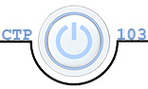**Julia Kovrigin** **CTP 103**

# Lab 1: Organizing Files and Folders – 35 points

Objective: Use a system file management utility to store and organize files and folders.

In this lab assignment, you will be working through the lab “Put Your File Ducks in a Row” on pp. 449-451 ***using your own computer*** and answer the questions and provide screenshots as indicated in this assignment. The instructions are generalized so you can do the assignment on either a PC or Mac. If you have any trouble understanding how to do a specific task, see your instructor or search a video tutorial online.

##### Section I: File Explorer (Windows) and Finder (Mac) – 5 points

Before you begin this assignment, it is important that you have a good understanding the features of your file management utility. There are many 3rd party file management utilities but we are going to concentrate on the one that came with your operating system. For PCs, it is “File Explorer” and for Macs it is “Finder”. Please watch the tutorial videos below based on YOUR operating system (if you are using a version of Windows other than Windows 10, do a video search on File Explorer for your version of Windows.)

PC: [Windows 10 File Explorer Part 1](http://www.top-windows-tutorials.com/windows-10-tutorial-9-exploring-file-explorer/) and [Windows 10 File Explorer Part 2](http://www.top-windows-tutorials.com/windows-10-tutorial-10-file-explorer-part-2/)

Mac: [Organizing Your Files and Folders Part 1](https://www.youtube.com/watch?v=X4TwDcVelpc) and [Organizing Your Files and Folders Part 2](https://www.youtube.com/watch?v=xKk8L3NEFRY)

1. After watching the videos, in 3-5 sentences, describe what features of the file management utility that you currently use and features that were new to you. (Use complete sentences and proper spelling and grammar.) **5 points**

I currently use file explorer to navigate documents that are saved on my laptop. I also use the detail feature in the view options to find and sort documents that I want to share or attach when emailing. The features that are new to me are preview pane and detail pane. These features will really help me to find and organize my files proficiently.

1. To prepare for this assignment, make sure that you can see file extensions in your file management utility. In Windows, open **File Explorer** click the **View** tab and make sure there is a check in “File name extensions” in the **Show/Hide** group. On a Mac, open **Finder**, in the Menu bar choose **Finder > Preferences**, click the **Advanced** Tab. Select the box that says “Show all filename extensions”.
2. *Note: this assignment may seem elementary for an advanced user. If this is the case, please demonstrate your knowledge and use of the file management utility in your answers.*

##### Section II: Put Your File Ducks in a Row (pp. 449-451) – 15 points

*Note: Some students have already mastered the skill of file management so there may not be a dramatic difference in the “before” and “after”. When answering questions, you may discuss where you learned this important skill and how it has improved your workflow.*

1. **Desktop** – before you begin this assignment, take a screenshot of your desktop. **2 points**
   1. **PC** – With the Windows Snipping Tool (see [this video](https://youtu.be/ayi5-7QPNcA) for instructions), copy the desktop. Then right-click on the blue portion of the object below (not in the center) and select **Paste**.
   2. **Mac** – Press **Command** + **Control** + **Shift**+ **4** and select the desktop. Press Command + V to paste the image. (For a video on how to capture screenshots with a Mac, see [this video](https://youtu.be/1TFvKxF3E-A).
   3. **Note**: if you have a dual screen, please crop out the screen that is not necessary for the assignment. Also, please resize the image from the corner so that it takes up the entire width of the document.

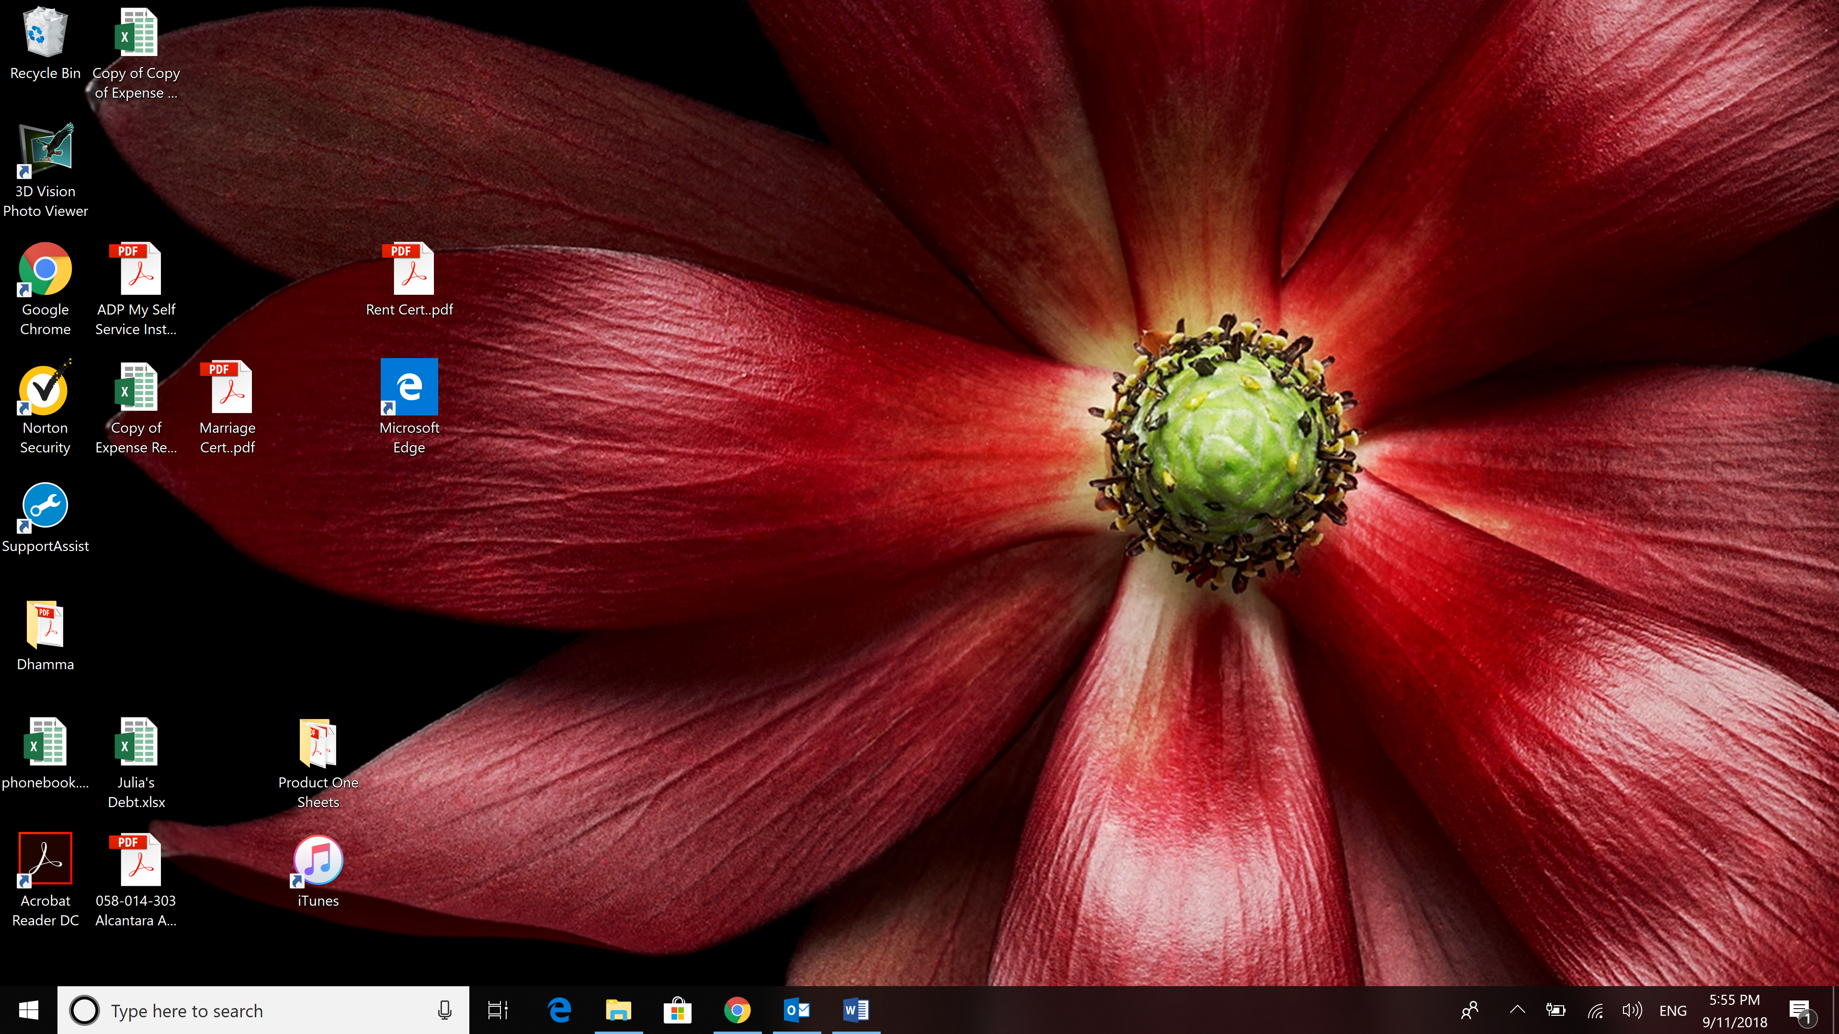

Go through #1 on p. 449 and total up your points. What was your score? **1 point** My score was 5.

1. **Root directory** – take a screenshot of the contents in your root directory (Macintosh HD or Windows C:) and paste it below. **2 points**

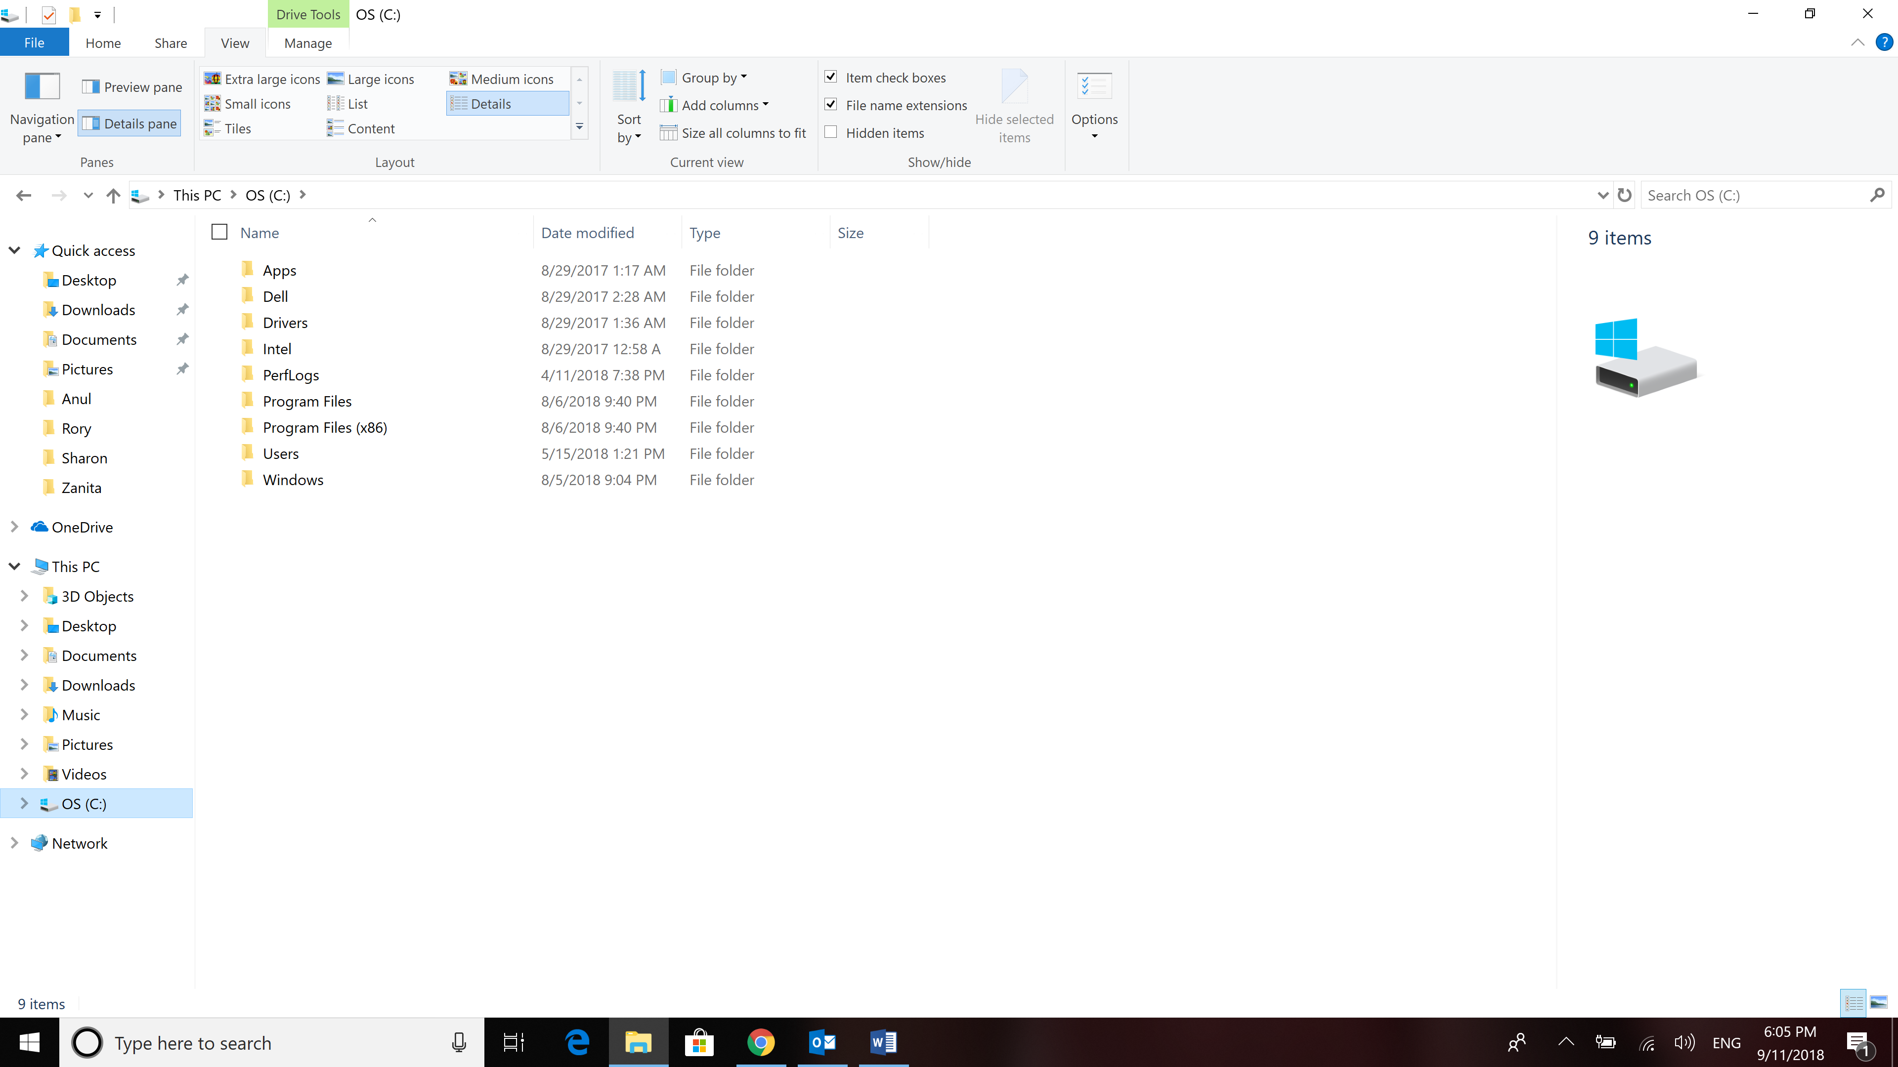

**Backup** – it is important to back up your important data files in case something happens to your computer. Where did you back up your files? **2 points** I backup my files on Google Drive

1. Before you move to #5 on p. 450, create a folder in **Documents** called **CTP 103**. Open **CTP 103**. Create three folders inside the CTP 103 folder – **Assignments, Labs** and **Project.**
2. Open the Labs folder and add three more folders – **Lab1**, **Lab2**, and **Lab3**
3. Save this document as **LastName_Lab1.docx**, replacing LastName with YOUR last name and save it in the **Lab1** subfolder of the **Labs** folder you just created.
4. **Quick Access or Favorites** – (NOTE: Windows 10 changed “Favorites” to “Quick Access”) follow the instructions in #5-6 and add some folders to **Quick Access**. Include the **Labs** folder you just created in **Quick Access**.
5. Clean-up your desktop as suggested in #7 and #8, then paste a screenshot of your new desktop configuration below **2 points**:

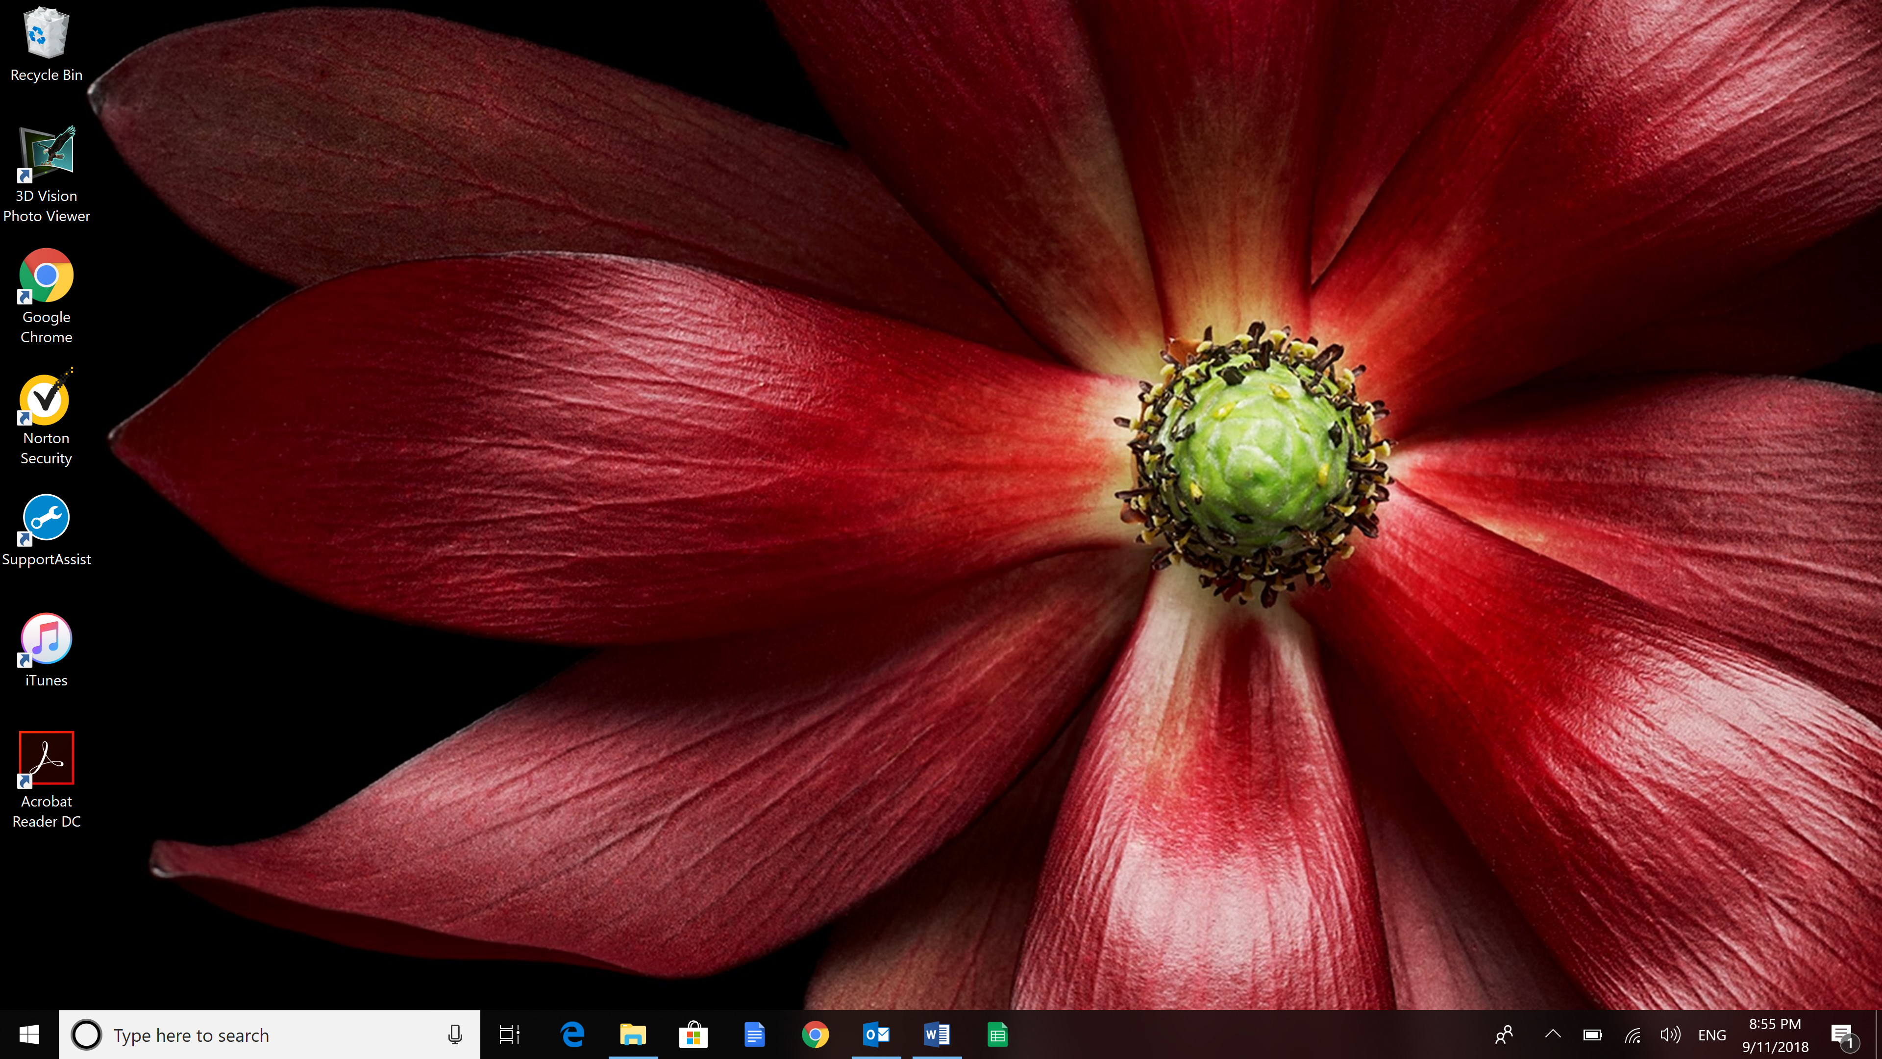

1. Organize your Documents folder as described in #9. Paste a screenshot of your Documents folder before and after your organization. **4 points**

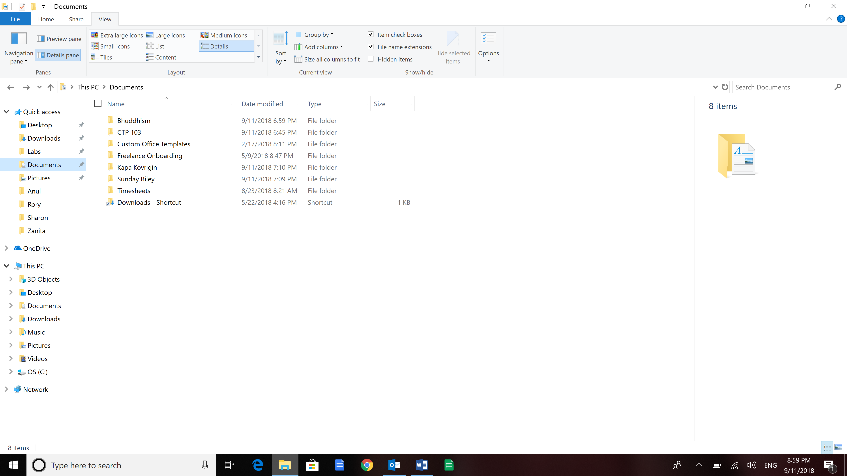

Before

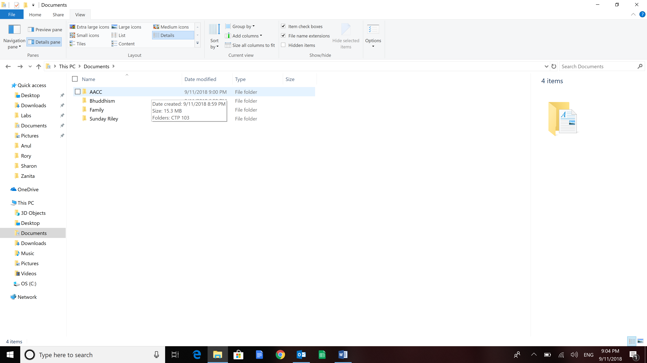

After

In 3-4 sentences, explain what you thought about this part of the exercise: **2 points** I thought this part of the exercise was very helpful. It made me see that I can organize my folders in a logical hierarchical structure that can be maintained as it grows. For example, before in documents folder, I just had a folder called Kapa Kovrigin. Now I have a folder called Family and a sub folder called Kapa Kovrigin.

##### Section III: Zipped (compressed) Folders

Zipped (compressed) files take up less storage space and can be transferred to other computers more quickly than uncompressed files. You can combine several files into a single zipped folder to more easily share a group of files.

When you download a zipped folder, you must unzip or extract the files to be able to use them. Click [here](https://www.youtube.com/watch?v=HzBF377jwto) to view how to do this on a PC. Click [here](https://www.youtube.com/watch?v=qGUK08S7j1A) to learn how to do this on a Mac.

1. Go to the assignment in Canvas and download the zipped folder called **Lab1_Files.zip** into your **CTP 103** Folder
2. Extract the files into the **Lab1** folder. You should now 6 files in this folder – the 5 in the folder you just extracted – File1.docx, File2.docx, File3.docx, riverhawks.jpg, and riverhawks.png, and this file (**LastName_Lab1.docx**).
3. If necessary, delete the **Lab1_Files.zip** folder.

##### Section IV: Copy, Rename, and Move Files and Folders

1. Rename the **Lab3** folder in the **Labs** folder to “Practice”.
2. Move the **Practice** folder to the **Lab1** folder.
3. Rename the **riverhawks.png** file to **riverhawks-nobackground.png**. Be careful to keep the file extension as is – only showing ONE file extension.
4. Open File1.docx and enter your name at the top/left of the document (press the Enter key to move the sentence “This is practice file to be used with Lab 1” down one line) and save the file as **LastName-File1.docx** in the same folder (**Lab1**)
5. Make sure that you are viewing the File Explorer window using the Details view with the Details pane showing. Click on **LastName-File1.docx** and make the following changes in the properties of the document (you can also make these changes by right-clicking and going to Properties and Details) (this grade is part of Section V):
   1. Title: Lab 1
   2. Authors: Add your first and last name
   3. Tags: File; Organization
   4. Content status: DRAFT

##### Section V: Final Screenshot and Submission – 15 points

1. Now you are going to setup a screenshot to demonstrate that you followed all the instructions in the lab. *This can be very tricky to make sure that everything is showing the way it should so pay careful attention.* Look carefully at the screenshot below. Verify the following (please see your instructor if you need help):
   1. Your folders are expanded on the left as shown so the main folder CTP 103 is showing with all the subfolders – Assignments, Labs and Project
   2. Expand the Labs folder so that the Lab1 and Lab2 folders are showing.
   3. Select the Lab1 folder so that its contents are visible on the right pane as shown – with the Practice folder, File1.docx, File2.docx, File3.docx, riverhawks.jpg, riverhawks-nobackground.png, LastName-File1.docx, and this document (LastName_Lab1.
   4. Select the **LastName_File1.docx** file on the right pane (the one you renamed with your name) so that the details of the file are shown.

|  |  |
| --- | --- |
| **Rubric for Final Screenshot** | |
| **Task** | **Points** |
| Folders expanded and folders/subfolders in the correct location | 5 points |
| Lab3 Folder renamed to Practice and moved to the Lab1 folder | 2 points |
| File1.docx is renamed with the student’s last name | 2 points |
| Details of file above showing with Title, Author (student name), and tags as instructed | 4 points |
| riverhawks.png renamed | 2 points |
| **Total** | **15 points** |

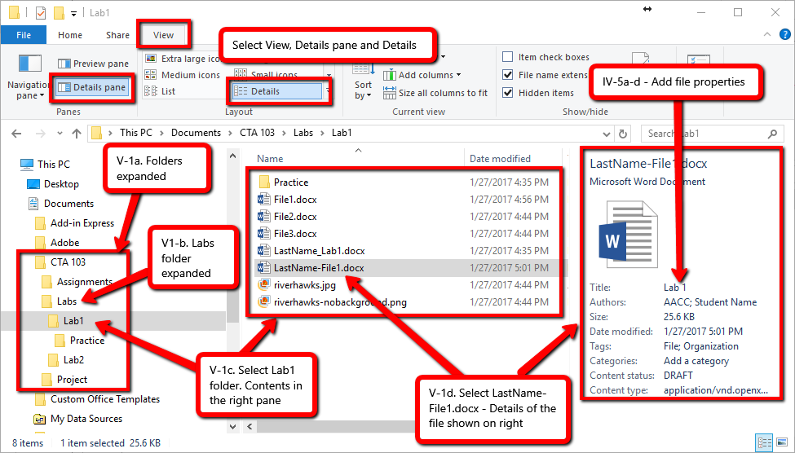

NOTE: Mac screenshots will look a little different. For example, the file properties are not the same.

* 1. Enter your screenshot below:

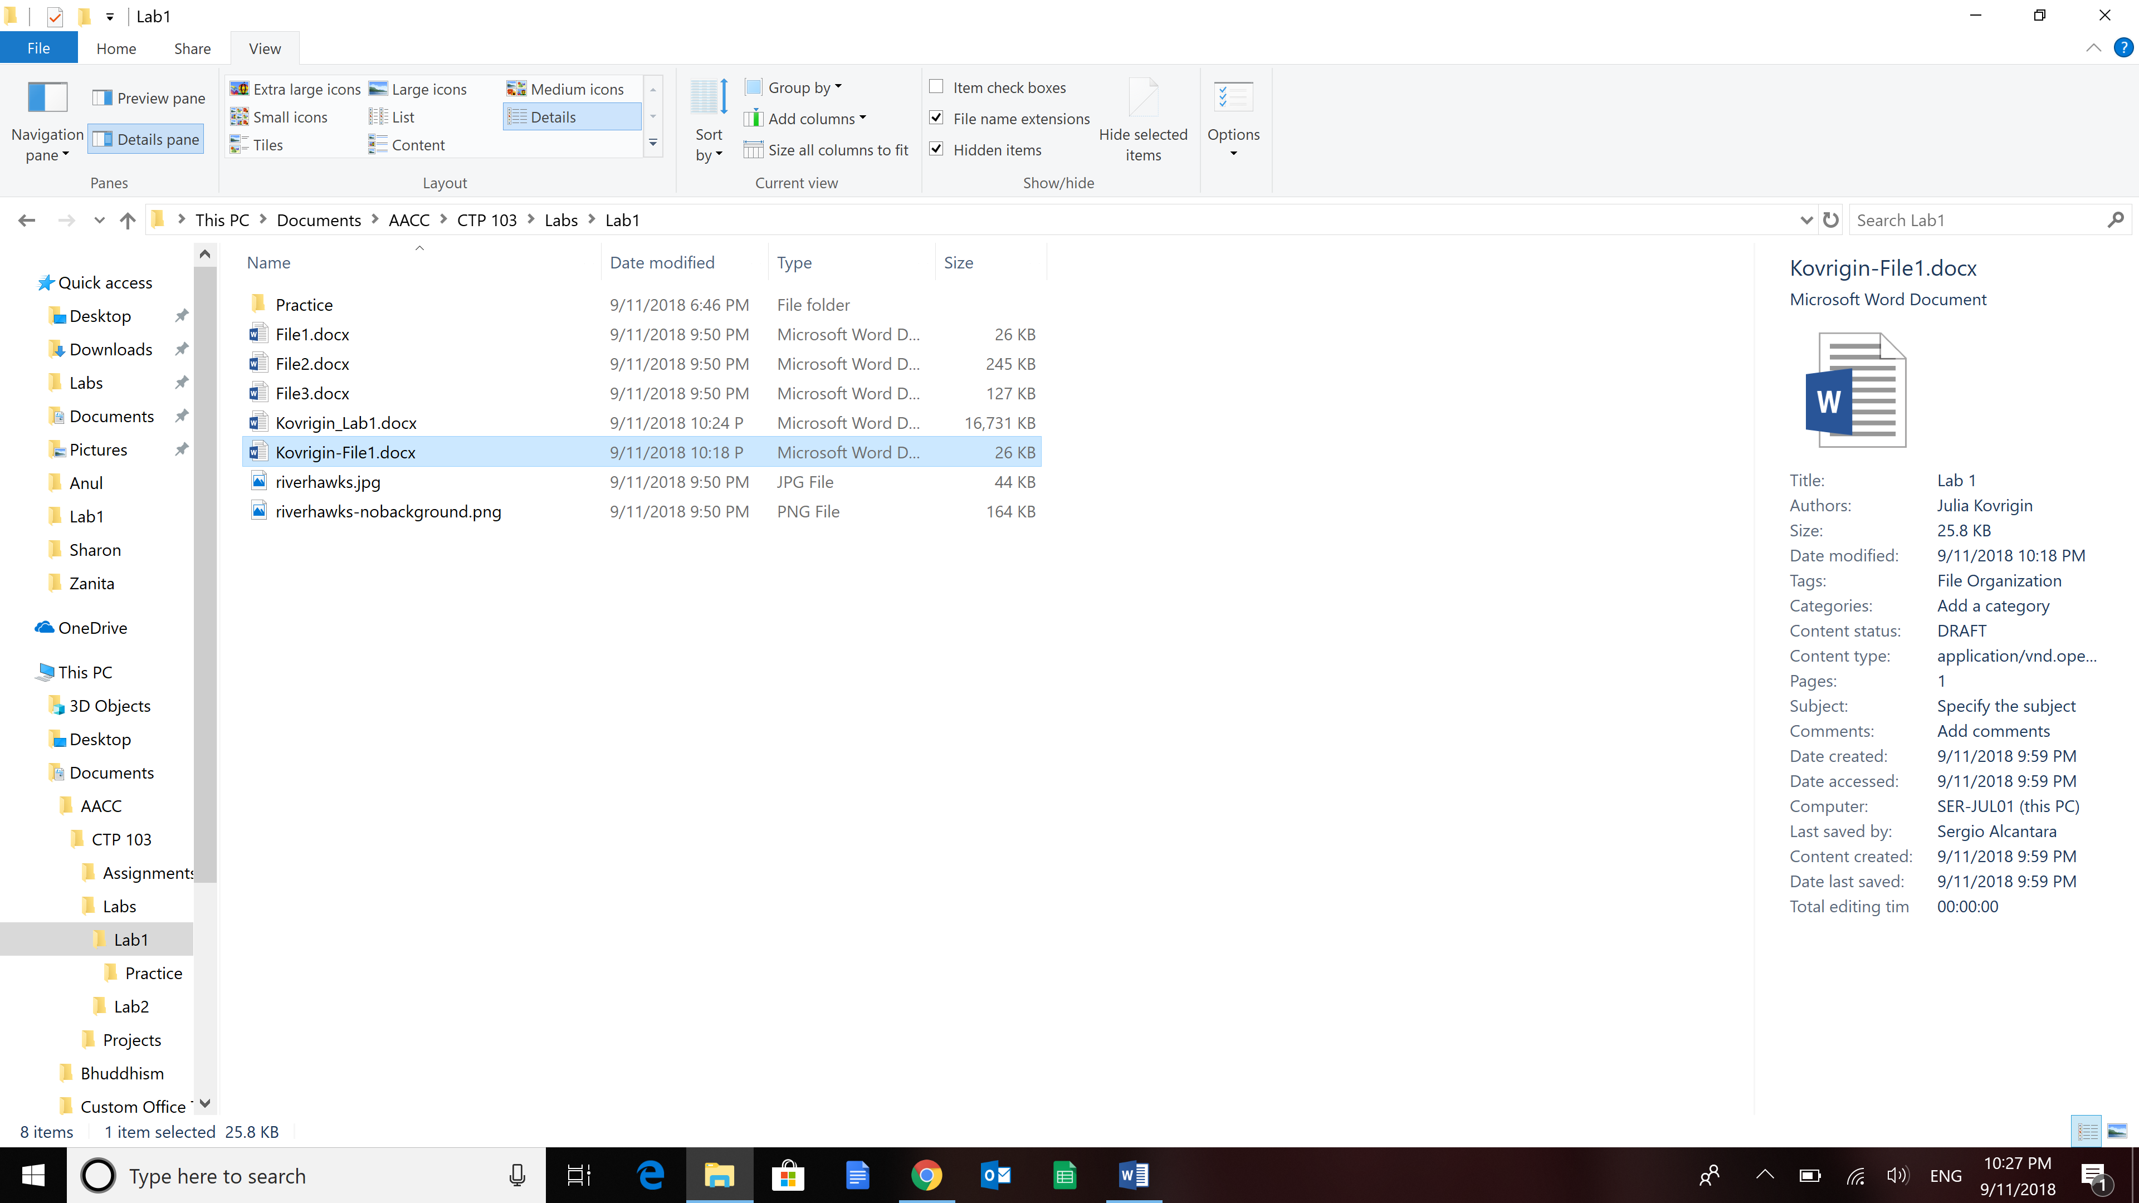

##### Submission Instructions

1. Make sure you have entered your name and section number at the top of this lab instruction document.
2. Save the document as **LastName_Lab1.docx (**as instructed in Section II.)
3. Submit it to the Lab 1 dropbox in Canvas by the due date.